Setting up JARViE Webserver Node

# Connecting the node to your home router

1. Upload the *JARViE_WebServer_Node.ino* program to the Arduino using the IDE.
2. Unplug the Arduino from your PC/Laptop
3. Attach the Ethernet Shield on top of your Arduino Board.
4. Plugin one end of the RJ45 cable to the shield and the other end to one of the ethernet ports on your home router.
5. Attach the JARViE PLM Shield on top of the Ethernet Shield.
6. Plug the PLM Shield into a wall outlet and confirm that the Arduino and Ethernet Shield are powered by confirming that LEDs are illuminated on each board.

# Accessing the node from inside your home (local access)

You may access the node from any device that is connected to your home internet. You will learn how to access the node from outside your home (remote access) in the next section.

1. Connect your phone, PC, laptop or tablet to your home internet via WiFi or ethernet connections.
2. Open a web browser (e.g. Internet Explorer, Chrome, Safari, etc.).



1. Open the *JARViE_WebServer_Node.ino* program and find the ip address.

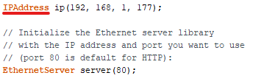

1. Enter the IP address into your device’s web browser as shown and the following page should appear. If this does not work setup port forwarding as instructed below.

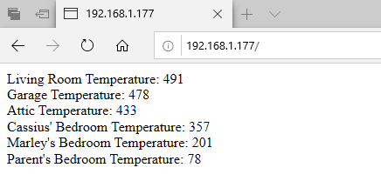

# Accessing the node from outside your home (remote access)

The following will instruct how to access the node from outside your home from any device that is connected to the internet.

## Configure your home route to perform port forwarding

1. The first step is to login into your router, for this you need to find the local IP of your router.
2. Open command prompt (cmd) inside windows. Type the following command. "ipconfig"
3. Now try to find the "Default Gateway" attribute, the value beside that is the Local IP of your router. Generally, router takes the first address inside the local network and assigns the consecutive addresses to the devices connected to it. (eg: 192.168.4.1).

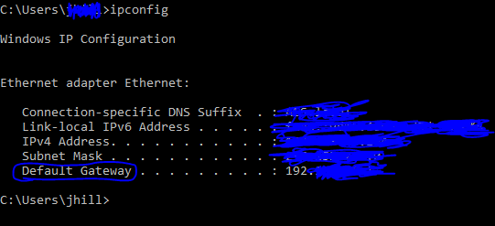

1. Open your browser and type the routers IP address inside the URL bar.
2. You should see a login page of your router.
3. There are too many routers out there to document instructions on how to perform port forwarding on each one. Use the internet and search how to setup port forwarding for your home router. Forward both UDP/TCP data to the IP address of your internet node (e.g. *192.168.177* per the webserver code snippet above).
4. Once port forwarding is setup find the global IP address of your router (for AT&T routers it’s the ***Broadband IPv4 Address*).**
5. Verify that one can access the Internet Node remotely by using your mobile phone. Disable the WiFi setting on your phone. Open a web browser and type in the home routers global IP address (e.g. *99.14.65.255:80*).

The following page should appear

